Evaluation of a Novel Stirling Engine
T. G. W. de Meijer, J. K. Carson
School of Engineering, University of Waikato, Hamilton
tgwd1@waikato.ac.nz, jkcarson@waikato.ac.nz

Abstract
Maecenas bibendum, arcu eu accumsan adipiscing, purus urna semper arcu, at dignissim sem est et arcu. Suspendisse dignissim leo justo, id fringilla purus convallis non. Integer felis neque, ultrices sit amet tellus non, iaculis scelerisque ipsum. Nunc lacinia sodales imperdiet. Nulla tristique laoreet nibh, sit amet iaculis elit tincidunt at. Suspendisse in purus a purus dignissim interdum. Mauris dapibus in tellus eget ullamcorper. Mauris tellus elit, suscipit semper nunc eu, pellentesque cursus sapien. Vivamus id est fringilla, pellentesque enim id, consequat ligula.

Introduction
Rodney Sharp, a Stirling engine enthusiast, has approached the university with a novel Stirling engine design. The engine has been designed from a mechanical point of view, but not thermodynamically. Because the engine deviates in its operation from “conventional” Stirling engines, the feasibility of this concept needed to be assessed.
Stirling engines are a form of external combustion engine working on the principles of the Stirling cycle. The theoretical Stirling cycle works at Carnot efficiency, giving Stirling engines the potential to achieve very high efficiencies. The ideal Stirling cycle comprises of four stages (Kongtragool & Wongwises, 2003).
  - Isothermal compression.
  - Constant volume heat addition
  - Isothermal expansion
  - Constant volume heat rejection
Since the isothermal expansion is done at a higher temperature and pressure than the compression, net work is done. During stage 2-3 and 4-1 heat is transferred alternatively from the working fluid to a regenerator and back again. The regenerator is what allows the cycle to reach Carnot efficiency, in theory (Çengel & Boles, 2007).
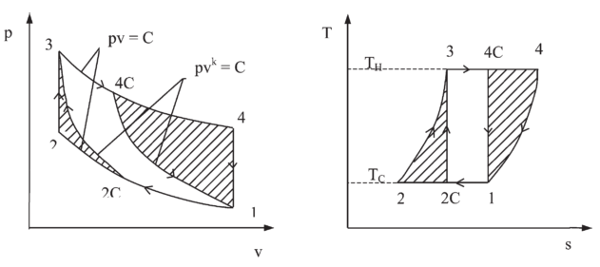
Figure 1 - Stirling cycle superposed on the carnot cycle. (Kongtragool & Wongwises, 2003)
In practice, the Stirling cycle does not reach the high efficiencies it is theoretically capable of. Perfect heat transfer is highly unrealistic in a rapidly reciprocating engine with physical size limitations. The regeneration process can also never be 100% efficient, and there are additional pressure and mechanical losses throughout the engine. These limitations on efficiency caused Stirling engines to be replaced by alternatives such as internal combustion engines (Çengel & Boles, 2007).
There is now a renewed interest in Stirling engines, driven by the increased focus on efficiency and sustainability. One of the prime advantages of the Stirling engine is its ability to work with any heat source, as it is an external combustion engine. This opens up possibilities to burn waste material such as biomass, use waste heat from industrial processes or even solar power (Li et al., 2012). Being an external combustion engine there is also more time for the combustion process, resulting in more complete combustion, releasing more energy with less pollution (Kongtragool & Wongwises, 2003). An additional advantage of the Stirling cycle is its low noise produced compared to internal combustion engines. This makes Stirling engines a good candidate for use in small scale combined heat and power systems situated in residential areas. Any waste heat from the engine is used to supply hot water, giving a very good overall energy utilisation (Li et al., 2012).
There are three main types of mechanical implementation to convert heat into mechanical energy using the Stirling cycle (Figure 2). The alpha layout uses two cylinders which alternately compress the gas in the cold space, move it through the regenerator into the hot space where it is then expanded. The beta and gamma layout both use a single piston for expansion and compression, with a displacer to move the gas between the hot to the cold side of the engine (Kongtragool & Wongwises, 2003). There are many variations on these basic layouts, ranging from coupling multiple engines together, to completely novel implementations.
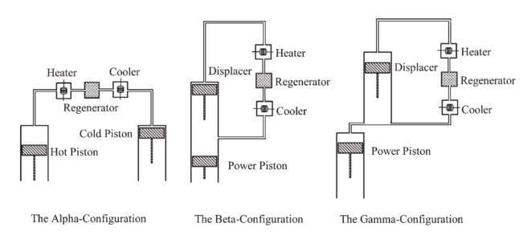
Figure 2 - Alpha, Beta and Gamma Stirling engine configurations (Kongtragool & Wongwises, 2003)

Design Methods
Martini divides Stirling engine design methods into first, second and third-order design methods (Martini, 1983). First-order design methods are used to get a rough estimate for a particular engine’s capability, based on existing engine designs. This will therefore never lead to a much improved engine design.
Third-order analysis is the so-called “nodal analysis”. A computer program is used to solve the basic equations of equilibrium for heat, mass and momentum across a large number of nodes in the engine. This approach has been successfully applied to a low temperature differential Stirling engine using COMSOL Multi-physics (Martaj, Rochelle, Grosu, Bennacer, & Savarese, 2007). A 3D computation fluid dynamics model in FLUENT has also been used to optimise a biomass Stirling engine (Mahkamov, 2006). Measurements taken on the real engine were used to tune the parameters used in the model. Although potentially accurate, this is a complex and time-consuming method of simulation.
Finally, second-order design methods take into account all aspects of a real engines performance but apply simplifications to ease the equations to be solved. These simplifications include assuming that that power losses can be determined using simple formulas and do not interact with other processes. A similar assumption is made for heat losses. Variations of the approach include the Schmidt method, adiabatic analysis and “simple analysis”. Here irreversibilities are subtracted from the theoretical adiabatic cycle (Martini, 1983).
A comparison has been made between the Schmidt method, adiabatic analysis and simple analysis (Snyman, Harms, & Strauss, 2008). The results were compared to experimental measurements taken on a Heinrici Stirling engine. It was concluded that simple analysis in particular is suitable as an initial design and analysis tool for Stirling engines.

The Sharp Engine
One such novel implementation is the focus of this research. It is a design made by Rodney Sharp, a Stirling engine enthusiast. The Sharp engine is a Siamese design, where the power piston is shared by two expansion spaces. Claimed benefits of this design include:
- Greater surface area for heat transfer
- Higher temperature design
- High compression ratio
- Direct conversion of pressure to rotational motion
- Displacer does not enter cold zone, reducing heat shuttling
- Increased cooling ability
The unique design features which enable these benefits are:
- Siamese design using common heat source
- Timed exhaust port to the cold zone
- Physical means of drawing working fluid through the cold zone
- Physical separation between hot and cold source during heating and expansion
- Combined displacer / regenerator
- Displacer becomes an extension of the hot zone
While reviewing the functioning of the model one obvious flaw was discovered in its functioning. By having the displacer/regenerator as an extension of the hot zone, it no longer regenerates effectively as it loses the capacity to cool the working fluid as it passes through after expansion. All further analysis was therefore done assuming this feature of the design is not implemented.
The hot side heat exchanger also did not have a greater surface area compared to most conventional power producing Stirling engines, although it was improved compared to smaller model engines. To offset this, the design enabled the use of exotic materials which could withstand higher temperatures. This increases the Carnot efficiency, potentially providing a net benefit in power and efficiency compared to a lower temperature heat exchanger with greater area.
The major way in which the design deviates from the conventional Stirling cycle is through the timed exhaust port. As a result of this feature, compression does not act on all the working fluid inside the engine and the pressure inside the engine (neglecting pressure drops) is not the same at all times, as in a normal Stirling engine.
The two research questions were therefore, what is the effect of the smaller hotter heat source, and what is the effect of the additional volume in the engine.

Model
The model used was developed by Urieli and Berkowitch (Urieli & Berchowitz, 1984), and is based on an adiabatic simulation. The Stirling engine model has the following spaces, with their associated suffix: compression (c), cooler (k), regenerator (r), heater (h) and expansion (e). Each interface has an associated double double suffix (ck, kr, rh, he). Enthalpy is carried across the interfaces by the mass flow rate ṁ at a temperature T. Positive flow is defined as from the compression to the expansion space. Since temperature in the expansion and compression spaces varies with time, the enthalpy flowing across the boundaries is conditional on the direction as follows:
if ṁ_{ck}’ > 0 then T_{ck} = T_{c} else T_{ck} = T_{k}
if ṁ_{he}’ > 0 then T_{he} = T_{h} else T_{he} = T_{e}
The total mass in the system is considered to be constant, and since there is no pressure drop P is constant throughout the system. The pressure losses are subtracted from the ideal model at a later stage.

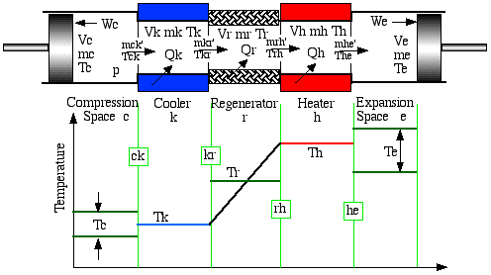
Figure 3 - Model on which calculations are based (Urieli, 2003)
Equations of energy and state are applied to each of the five cells, and linked by their pressure and mass relationships. A generalised cell is considered to derive the relevant equations (Figure 3). The rate of heat transfer into the cell plus the enthalpy convected into the cell must match the rate of change of internal energy plus work done on the surroundings:
dQ + (c_{p} T_{i} ṁ_{i} – c_{p} T_{o} ṁ_{o}) = dW + c_{v} d(m T)
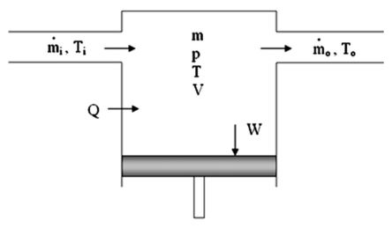
Figure 4 - Generalised cell (Parlak, Wagner, Elsner, & Soyhan, 2009)
We know the total mass in the system, M, to be constant. Substituting the ideal gas law into this relationship gives the following:
P (V_{c} / T_{c} + V_{k} / T_{k} + V_{r} / T_{r} + V_{h} / T_{h} + V_{e} / T_{e}) / R = M
The mean effective temperature of the regenerator is given by
T_{r} = (T_{h} - T_{k}) / ln(T_{h} / T_{k})
Expressions for the change in mass can be written for each of the heat exchangers. Since the volume and temperatures are considered constant, the differential forms reduce to dm = m dP / P = (dP/R) V / T
The total mass in the system is differentiated, and th. By susbsituting in expressions for dm_{c} and dm_{e} and simplifying, an expression for dP is obtained
$$dP =\frac{-γP \left({dV_{c}}/{T_{ck}} + {dV_{e}}/{T_{he}}\right)}{{V_{c}}/{T_{ck}}+ γ({V_{k}}/{T_{k}} +{V_{r}}/{T_{r}} + {V_{h}}/{T_{h}}}$$
From the expressions for dm_{c} and dm_{e} the change in temperature of the cooler and expansion space are also obtained.
From the overall cell energy balance, heat transfer into and out of the heat exchangers (dQ_{k}, dQ_{r}, dQ_{h}) is derived.
Finally, the work done in the compression and expansion space is given by P dV, completing the full set of equations needed for the ideal adiabatic model (Figure 4).
Since the equations needed to analyse the Stirling engine are non-linear, a numerical approach must be used to solve them. The operating temperatures and gas properties are specified, and the total working mass is obtained using a Schmidt analysis (Urieli, 2010). Frequency is also specified to work out time related effects such as power and thermal conduction losses. The volumes and volume derivatives are a function of the specific engine geometry.

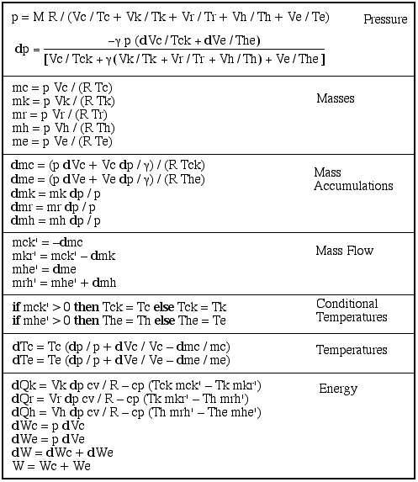
Figure 5 - Equation summary for the ideal adiabatic model (Urieli, 2010)
The whole system of equations is solved as a “quasi steady-flow” system. It is solved over a complete cycle as a series of integrations. During each integration interval the mass flows between the cells remain constant, approximating the continuous solution as a series of short straight lines. The system is an initial value problem which is solved using the fourth-order Runge-Kutta method (Urieli, 2010). Although the initial compression and expansion space temperatures are not known, these can be found using an iterative approach, integrating through multiple cycles until steady state is reached.

Volume Derivatives
The volume and volume derivatives of the Sharp engine were derived from the engine geometry. The crank angle start position was defined as the point where the power piston covers the exhaust port, and moves to the right (Figure 5).
θ1 = θ3 = θ
θ2 = sin⁻¹(sin(θ) · R1 / R2) = sin⁻¹(sin(θ) / 2)
θ4 = θ2 · R3 / R4 = 2 sin⁻¹(sin(θ) / 2)
θ5 = -sin⁻¹(sin(θ+π/2) · R6 / R5)
= -sin⁻¹(0.42 cos(θ))
The compression space and expansion space angles are a function of the swept angles inside the engine (Figure 6). The compression space angle is 180º - 20 º – 51 º – 23 º - θ_{e}, and the expansion space angle is given by θ5 + θ5_{max}. All dimensions are entered in meters or radians.
θ_{c} = 1.5335 - θ_{e} - θ4
= 1.1199 + sin⁻¹(0.42 cos(θ)) - 2 sin⁻¹(sin(θ) / 2)
θ_{e} = θ5 + θ5_{max} = 0.4334 -sin⁻¹(0.42 cos(θ))
To convert these angles to volumes, they are multiplied by swept area and depth
V = θ · 110 π (R_{o}² – R_{i}²) / 2 π = θ · 0.001011
Therefore
V_{c} = 0.001011 · [1.1199 + sin⁻¹(0.42 cos(θ)) - 2 sin⁻¹(sin(θ) / 2)]
V_{e} = 0.001011 · [0.4334 -sin⁻¹(0.42 cos(θ))]
$$dV_{c} = \frac{-0.0004245·\sin\left(θ\right)}{\sqrt{1-0.1764∙{cos⁡(θ)}^{2}}}- \frac{-0.001011·\cos\left(θ\right)}{\sqrt{1-0.25∙{sin⁡(θ)}^{2}}}$$
$$dV_{e} = \frac{0.0004245∙sin\left(θ\right)}{\sqrt{1-0.1764∙{cos⁡(θ)}^{2}}}$$
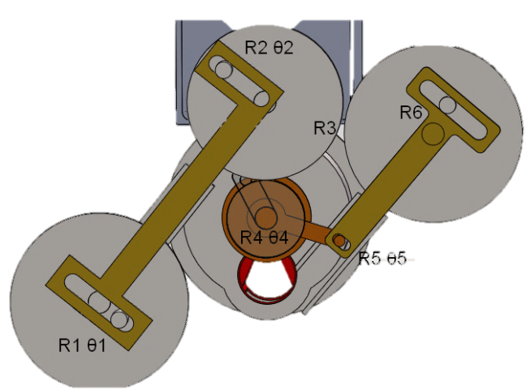

Figure 6 - Geometry of the Sharp Engine drive mechanism
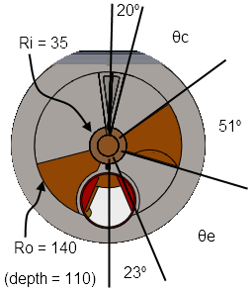

Figure 7 - Dimensions (mm) and swept angles of the Sharp engine

Figure 8 - Compression and expansion space volume variations in the Sharp engine

Heat Transfer Coefficient
The heat transfer in the engine is modelled based on standard convective heat transfer, applied over a cycle
Q = h · A_{w} · (T_{w} – T) / ƒ
Where h is the heat transfer coefficient, A_{w} is the wetted area, T_{w} and T are the wall and gas temperatures and ƒ is the frequency. Applying this equation to the cooler and heater (Figure 8)
Q_{k} – Q_{rloss} = h_{k} A_{wk} (T_{wk} – T_{k}) / ƒ
Q_{h} + Q_{rloss} = h_{h} A_{wh} (T_{wh} – T_{h}) / ƒ
Where Q_{rloss} is the regenerator heat loss.
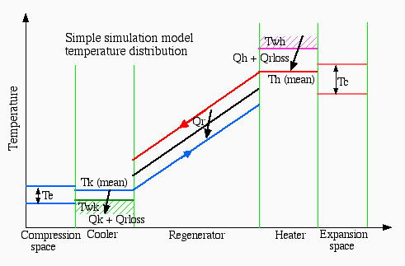
Figure 9 - Simple simulation model temperature distribution
To determine the effect of the smaller but hotter heat exchanger used in the Sharp engine, a comparison between two Stirling engines was modelled. Both engines were similar in all geometric parameters except heat exchanger size and type. The volume and swept volume were identical to the Sharp engine.
The conventional Stirling engine of this size most commonly uses tubes for heat transfer in the hot side. First the Reynolds friction factor is determined (Reynolds number multiplied by coefficient of friction). Because of the oscillating flow, it is assumed to always be turbulent. The Blasius relationship is therefore applied for all Reynolds numbers. This has been found the most accurate way to model the reciprocating flow (Urieli, 2010).
fr = 0.0791· Re^{0.75}
The heat transfer coefficient is determined based on the Reynolds friction factor
h = fr µ C_{p} / (2d · Pr);
Where µ is the dynamic viscosity, C_{p} is the specific heat capacity at constant pressure, Pr is the Prandtl number and d is the hydraulic diameter.
The only difference in the heat transfer coefficients
A comparison between the Sharp and conventional Stirling engine modelled shows the Sharp engine does have a lower heat transfer area, but is assumed to be at a higher temperature ().
There is also a third engine for some reason, not known to man.
Table 1 - Heat exchanger parameters of modelled engines
 | Conventional | Conventional Slots | Sharp
Hx Type | Tubes | Slots | Slots
T_{h} | 700ºC | 1200ºC | 1200ºC
A_{w} | 7.147×10⁻² m² | 3.6×10⁻² m² | 3.6×10⁻² m²
V_{h} | 8.13×10⁻⁵ m³ | 9×10⁻⁵ m³ | 9×10⁻⁵ m³
Vc | 2.45×10⁻⁴ m³ | 2.45×10⁻⁴ m³ | 15×10⁻⁴ m³
Vh | 2.45×10⁻⁴ m³ | 2.45×10⁻⁴ m³ | 8.76×10⁻⁴ m³
Cooler tubes | 50 | 50 | 100

Results and Discussion
 | Conventional | Conventional Slots | Sharp
Power | 419 W | 564 W | 921 W
Efficiency | 37% | 48% | 32%
Carnot Efficiency | 70% | 80% | 80%
Pressure Loss | 126 W | 70 W | 147 W

(Effect of each of the things that make Rodneys engine different.)
In the discussion, state that the assumptions made for the heater are not that accurate.

Discuss the extra volume that is connected, and the effect thereof on the maths
Discuss the heat transfer coefficients that were used. And how these actually work.
Discuss the pressure loss stuff?
The two separate parts of the experiment. 1. The actual modelling of the actual engine.
2. looking at the effect that the higher temperature can have on the efficiency of the engine (this point would make for good discussion)

Conclusions and Recommendations
The model needs to be extended to include the dead volume. Then a complete analysis of the system can be done.

Acknowledgements
The author would like to thank Dr James Carson for support, and Rodney Sharp for providing the engine concept and support in understanding it.

References
Çengel, Y. A., & Boles, M. A. (2007). Thermodynamics: An Engineering Approach, SI Version. New York: McGraw-Hill Higher Education.
Kongtragool, B., & Wongwises, S. (2003). A review of solar-powered Stirling engines and low temperature differential Stirling engines. Renewable and Sustainable Energy Reviews, 7(2), 131–154. doi:10.1016/S1364-0321(02)00053-9
Li, T., Tang, D., Li, Z., Du, J., Zhou, T., & Jia, Y. (2012). Development and test of a Stirling engine driven by waste gases for the micro-CHP system. Applied Thermal Engineering, 33-34, 119–123. doi:10.1016/j.applthermaleng.2011.09.020
Mahkamov, K. (2006). Design Improvements to a Biomass Stirling Engine Using Mathematical Analysis and 3D CFD Modeling. Journal of Energy Resources Technology, 128(3), 203. doi:10.1115/1.2213273
Martaj, N., Rochelle, P., Grosu, L., Bennacer, R., & Savarese, S. (2007). STIRLING ENGINE SIMULATION : NON - ISOTHERMAL FLOW / STRUCTURE INTERACTION. In Comsol Conference 2007 (p. 2007). Grenoble, France.
Martini, W. R. (1983). Stirling Engine Design Manual (2nd ed.). National Aeronautics and Space Administration.
Parlak, N., Wagner, A., Elsner, M., & Soyhan, H. S. (2009). Thermodynamic analysis of a gamma type Stirling engine in non-ideal adiabatic conditions. Renewable Energy, 34(1), 266–273. doi:10.1016/j.renene.2008.02.030
Urieli, I. (2010). Stirling Cycle Machine Analysis. Retrieved September 05, 2013, from http://www.ohio.edu/mechanical/stirling/me422.html
Urieli, I., & Berchowitz, D. M. (1984). Stirling Cycle Engine Analysis. Ann Arbor: A. Hilger.

