The Herring Skiff by Ira Einsteen

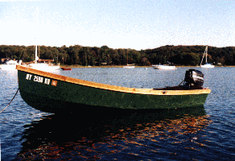 | 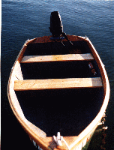

Introduction

This was a project I started in order to put an old 9.8 hp Mercury outboard to work. I've had it for years and was under the impression it was still running fine. It wasn't, but that's another story. I also thought it would be nice to have a small trailerable boat I could tow to various places around Long Island as the mood struck me. I have an old, or should I say "classic", 1936 Baltzer cruiser. At 28' it's hardly trailerable, and at its' 7 knot cruising speed I don't get to cruise as much of Long Island's waters as I'd like to. A small, light skiff would fit the bill nicely for those times when I'd want to do a bit of exploring in either the Peconic or Great South Bays, and would want to go a bit farther than a canoe or small paddling boat could take me. The "Double Paddle Dory" I wrote about last year is great for the rivers and small lakes of Long Island, but does limit me to solo forays without much gear. I'm very lucky in that I have 2 daughters and a wife who like to share my time, and wanted something they could safely fit into. I wasn't looking for speed, (the fact that I limited myself to 9.8 hp took care of that), but I wanted something that would have a bit of get up and go. I was hoping for 12-14 knots. In explaining how the skiff goes together, I won't go into alot of detail on technique. If you’ve built these type of boats before, you'll be familiar with what I'm talking about. If you haven't, you'll be well served by buying or borrowing from the library any of the how-to books on either stitch and glue, or tack and tape construction. I cut my teeth on Dynamite Payson's books, and couldn't recommend them more highly.

I've done a good bit of building using the tack and tape technique, which I find relatively easy and quite enjoyable. It's amazing how quickly you see results, with most small hulls taking shape in a couple of days. I can certainly admire the craftmanship of traditional small boat construction, but can't see the necessity of using those methods from a purely practical point of view. Properly maintained, a tack and tape boat may last as long or longer than one built using traditional methods, so long as basic common sense and some semblance of craftmanship is adhered to. If there seems to be a problem with these boats from a longevity point of view, I don't think it's anything inherent in their materials or design, but the fact that because they go together so easily and quickly, we don't tend to maintain them with as much care as we would a traditionally built Whitehall pulling boat. I have an 11 year old Bolger nymph dinghy, (a tack and tape "instant" boat), that's as solid as the day I launched her. She's pulled over rocks every time I use her, and banged about with each tide where she's chained up, gunnel to gunnel, with other dinghy's in the dinghy storage area of our harbour. I'd like to see a traditionally constructed boat take that type of abuse!

Another plus for tack and tape construction is cost. Nothing more exotic than epoxy is called for, with everything in this skiff except the epoxy, fiberglass tape, and three cleats, purchased at the local Home Depot. For this skiff the total material cost was around $250.00, including paint, varnish and lettering, and for a 12' skiff that's not bad. I continue to sing the praises of luan ply. I used 1/4' exterior and it worked out great. At $10.00/sheet it's got to be the best buy in the lumber yard. I didn't sheathe the skiff with fiberglass cloth in large measure because I knew the luan would finish up so nicely. It'll ding up over the years, and scratches will accumulate, but the same can be said about any type of finish. The hull can always be sheathed if it becomes necessary down the road, and not sheathing it saves a hell of alot of initial effort. The skiff looks fine now after a couple of months of use, with the paint finish holding up beautifully.

As for the design, I wanted something that I could feel comfortable taking out into Long Island Sound, as well as the bays I mentioned previously. It's a small boat, and common sense must rule, but there are many days where boating on the Sound and like waters is possible and safe in a boat of these dimensions. Because there can be some sloppy conditions, I wanted a vee bottom. Not a deep vee, but enough so I wouldn't feel undue pounding heading into a chop, and to give me some bearing in a following sea. I also wanted a prominant sheer. This design is clearly dory inspired. I would call it a dory-skiff if I had stayed with a flat bottom, and it is very much like a dory in appearance in large part due to the sheerline. You get a sheerline like this when you keep the upper planks, or in this design, the upper or side panel, equal in width throughout its length and design in some topside flare. If there is no flare the sheer will not sweep upwards like you see here or in the dory. As soon as you add the flare, though, your sheerline sweeps skyward. The more flare, the more upsweep. I have a good bit of flare in this design, hence the prominant sheer. A nice bonus of flare is increased reserve stability, one of the attributes that make dorys tender but seaworthy. I wouldn't describe this skiff as tender, but it's not as rock solid as a flat bottom would be.

Bill of Materials

1. | (5) 1/4" x 4' x 8' luan ply | $50.00
2. | (3) 2" x 4" x 12' douglas fir | $15.00
3. | (1) 2" x 6" x 12' douglas fir | $7.00
4. | (6) 1" x 2" x 8' firring strips | $4.00
5. | (2) 1" x 12" x 6' pine | $14.00
6. | (1) 1" x 12" x 3' pine | $4.00
7. | (1) 1" x 6" x 6' pine | $5.00
8. | assorted hardware | $30.00
9. | 2 gallons epoxy | $70.00
10. | 50 yards 4" fiberglass tape | $35.00
11. | (2) quarts enamel paint | $15.00
12. | (1) quart u.v. inhibiting poly | $8.00
TOTAL |  | $257.00

Build Instructions

I built the skiff more by eye than design. I knew I wanted a v-bottom, so I cut the transom out from the end of a sheet of 1/4" ply with about 15 degrees of deadrise. (See figure 1.) I should mention here that I designed the transom for a long shaft outboard, (24"), and if you're using a shorter shaft, you'll have to make provisions, either with a cutout in the transom I show, or with a different upper profile to the transom.

I then made up a form with the same deadrise and bottom dimensions as the transom but with a good bit more flare in the topside area, to use as the mid-point station form. (See figure 2.) I used the same deadrise and bottom dimension because I wanted the run from the mid-point aft to be a straight run. I thought that with only 9.8 hp, planing in anything but the most rudimentary sense would be anything but a fargone conclusion, and I wanted to give the engine as much help as I could.

The form is placed 6 feet forward of the bottom of the transom on the strongback. The cross brace you see in the drawing is to support the mould on the strongback. The placement of the support is arbitrary, as is the height of the transom on the strongback. I have them where I do because that gave me a comfortable working height after I attached them to the strongback. (See fig. 3 and 4) I used 1" x 4" firring strips to make up the form. This is a throw away after the hull is completed, so any scrap wood you have laying around that's sturdy would do the job.

Constructing the strongback is the next step. Two saw horses with an 8 foot 2" x 4" nailed on top will do the job. The next step is attaching the transom and form to the strongback. I had to screw a scrap piece of 2" x 6" to the transom to allow me to fasten it securely in place. I set the rake of the transom by eye. It turned out to be around 15 degrees, which worked out fine. I then cut out and butt-jointed the sides to give me the 12' side panels I wanted. You could scarf the plywood, but the butt joints work, are easier, and don't look bad. As you can see in figure 5, the side panels are simple rectangles with triangular cuts to give the necessary rake to the stem and transom. The rake for the stem was kept to a minimum, since I wanted something very close to a plumb stem profile. (See fig. 5). Also, it's a good idea to stagger the butt blocks when you set the panels up on the boat, leaving one side panel butt toward the bow, and one toward the stern.

One quick note about resin. I used epoxy. I wouldn't recommend you using polyester resin unless you plan on completely sheathing the hull. I only taped the inside and outside seams. I wouldn't trust taped only seams like I have here with polyester resin.

The next step is bending the side panels around the transom and mid-point form. (See fig 6) There isn't a hell of alot of stress, so I was able to simply tack the panels in place at the mould and the transom. What I did at the stem was drill 3 sets of small holes and stitch the stem together with wire. Now carefully eyeball everything for fairness. You could probably come up with some fancy way to measure for fairness, using that 9th grade geometry we've all forgotten, but I've generally found that if it looks fair, especially in small boat plywood construction,it's close enough. Add epoxy and wood flour fillets at the transom and stem, bed 4" fiberglass tape into them, saturate with epoxy, and let dry.

The bottom panels go on next. You'll have to butt block 2 pieces of luan together, (just like with the side panels), in order to get the roughly 11' length you'll need. Instead of panels 15" wide, you'll here need ones that are 20 1/2" wide. Again, stagger the butt blocks so one is fore, and one aft. Lay two pieces of plywood over the bottom and tack them to the transom. The edges of the plywood that meet in the keel area are left perfectly straight and butt against each other. I drilled a half dozen sets of holes along that edge and tied the keel edges together with wire. You then have to cajole the chine edge of the bottom panels to meet the side panels, and stay fair. Drill some holes and wire together the bottom and side panels. The panels aren't going to cooperate fully, but if you don't get too angry at them, you'll get them to lay down fair.

You then have to mark the bottom panels for cutting. (Where the bottom panel meets the side panel). You'll also have to mark a stem profile onto the bottom panels. Just continue the rake of the stem from the side panels and round nicely into the keel area so the stem looks like a boat stem should look. (You'll know what I mean when you get there.) And don't be too afraid of messing up. What's nice about tack and tape construction is that it's very forgiving. Half inch gaps in the ply joints are no problem so long as they aren't too numerous. The epoxy fillets, and fiberglass tape on both sides cover alot of mistakes-and does it safely.

Now untie thebottom panels, cut them, rewire them to the side panels and transom, and you're set to tape the inside seams of the hull. You should have a friend help you turn the hull over after unfastening it from the strongback. Filet and tape the remaining inside seams. Turn the hull back over and round all the plywood edges. A belt sander does the job quickly and easily. Tape all outside seams and voila, you have a hull. The boat is now about half done.

I wanted a small keel, both for strength and directional stability. I ripped a 9' 2" x 4" to 2 1/2" wide, then cut that down to give me a piece roughly 1" X 2 1/2". I formed it as in figure 7, then glued it to the bottom with thickened epoxy. I also screwed it down from the inside of the boat with 8 or 9 brass woodscrews.

I wanted the boat to float high if fully swamped so I put flotation under all three seats. I boxed the seats in with luan cut to fit the profile of the hull, then taped these supports in place. (4" fiberglass tape over epoxy and wood flour filets.) See fig. 7. These seat supports also add alot of strength to the hull structure. The boat is very stiff, tortionally, and the seat supports are a big reason.

I then screwed 1" x 2"s to the inside edges of these seat supports, and screwed down 1" x 12" pine for the seat tops. For flotation I used styrofoam blocks cut to fit. Pour in place foam would certainly work, but you'd pay more for the foam than the boat cost me. If you spend any time at all walking along the high tide line on your favorite beach, you can probably salvage all the foam blocks you'll need for this project in a very short period of time. You'll also be cleaning up the environment a bit.

You'll want to drill 1" holes at the bottom point of the seat supports. These act as limber holes and allow water to drain to the stern of the boat for removal.

The transom knee went in next. I used 2" by 6" stock and cut it to fit. (See fig 8.) This was glued with thickened epoxy and screwed from both the transom and the bottom.

For the breast hook, motor board, and stern quarter knees, I again used 2" x 6" stock. (see fig 8.) It's just a matter of fitting these pieces to the hull. I don't mean to make this seem easy, because it's not, and it's the only part of this boat project that calls for relatively close tolerances. (You'll even have to make two compound cuts for each stern quarter knee!) But take some time, because a good job here really dresses up the boat. A traditional Whitehall this boat may not be, but woodwork impresses the hell out of everyone. Don't hesitate to re-cut new pieces if you're a bit off. We're talking 2" x 6" stock here, hardly a big deal money wise.

I cut the outside motor board from 1" x 6" pine. For the gunwales and inwales, I ripped down two 14' 2" x 4"s to 3", then cut those in half to make pieces roughly 11/16" by 3". They bend nicely in that thickness and add an incredible amount of rigidity. And by the way, if you're able to fit the inwales in one piece without ruining one or maybe two, God bless ya. I screwed the gunwales in place at bow and stern from the outside with 2" brass screws, (into the breast hook and stern quarter knees),and from the inside with 3/4" screws. The inwales are screwed in place from the inside with 1 1/4" screws. All screws that show are countersunk and filled with wood putty prior to varnishing.

The finishing details-sanding, painting, varnishing the brightwork, (the bright work consists of inwales, gunnels, breasthook, stern quarter knees, and inner and outer motor boards),will take as much time as you're willing to give. Add some cleats, a mooring bit, a towing eye, and there you have it; a handsome, serviceable, 12' skiff. For roughly the cost of a new set of tires; and a bit of wholesome, relaxing labor.

Summery

A quick note on how she performed. As I noted in the first paragraph, the 9.8 hp I thought was in good shape needed a bit of work. Compression was down in one cylinder due to ring wear and I couldn't get the engine close to maximum rpm. The skiff still made around 10 knots, a measured mile taking around 5 minutes. I was able to get her up to around 12 knots with a borrowed 8 hp. One of my winter projects is rebuilding the 9.8, and I'm sure she'll perform a good bit better than that.

One mild disappointment is that with one person aboard she trims better when steered from the middle seat than when steered from the more usual rear seat position. One person sitting on the rear seat throws the trim off enough to affect performance. When steering from the middle seat a tiller extension becomes necessary. With two people aboard, (one sitting on the middle or foward seat with the helmsman on the rear seat), she trims fine. This is a common problem with small skiffs. You'd have to design in more waterline beam aft to offset this, and that would affect sea-kindliness to a certain extent, and would also affect rowing performence. While I didn't design this as a rowboat, she does row adaquately and I'd hate to have this quality denigrated.

As to rowing, with one person aboard and no engine she actually does quite well. With more than one person aboard or with one person aboard and the outboard in place, she starts to drag a bit. She still performs respectably, however, and could still be rowed home without too much difficulty if the motor failed.

Overall, the boat works well. She's light and very easily trailered. I've used her perhaps a dozen times, and am always approached by strangers at the boat ramps asking questions and admiring her lines. She'll be used and enjoyed extensively, proudly proclaiming to all that there are still a few to whom the spirit of doing for oneself is both practical and satisfying.

Plans

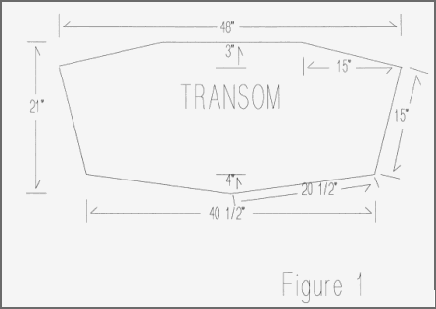

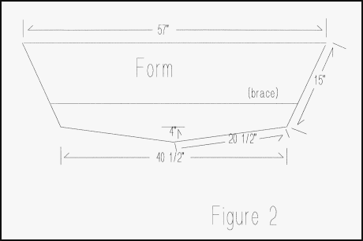
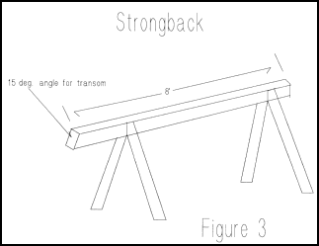

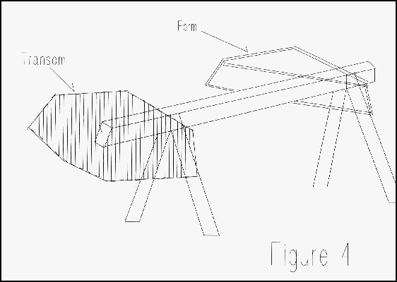

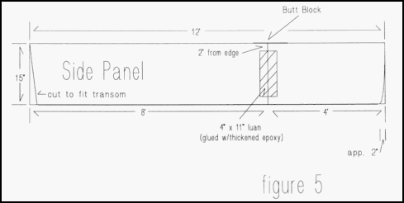

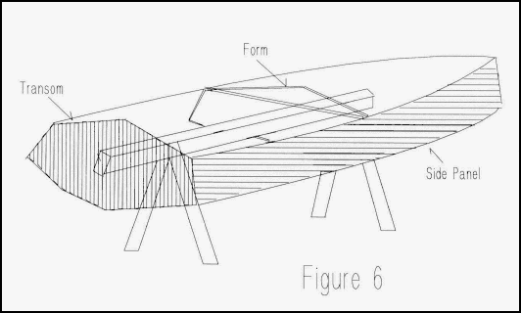

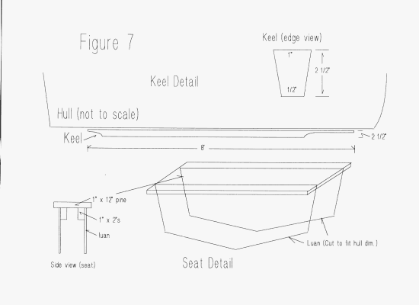

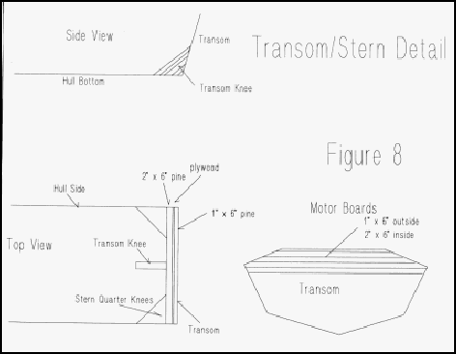
c

